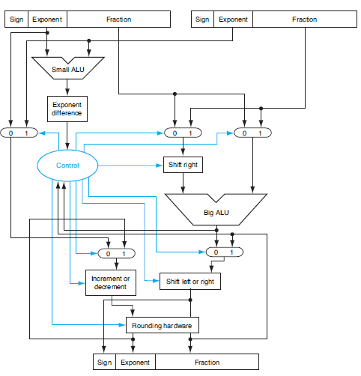

compare

exponents

shift small number right

add

normalize

round

First, the Exponent of one operand is subtracted from the other using the small ALU to determine which is larger and by how much. This difference controls the three multiplexores; from left to right, Second they select the larger exponent, the significance of the smaller number, and the significance of the larger number. The smaller significance is shifted right.

Third ,the significands are added together

using the big ALU.

Fourth,The normalization step then shifts the sum left or right and increments or decrements the exponent.

Finally, Rounding then creates the final result, which may require normalization again to produce the final result.